History 049: The Soviet Century

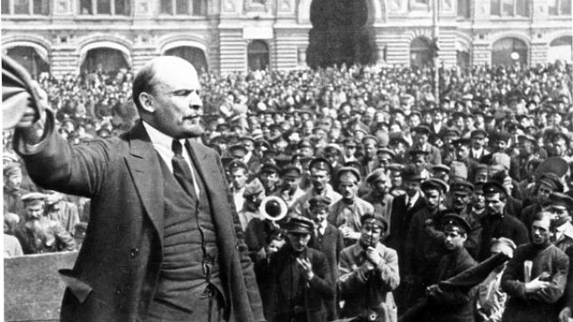

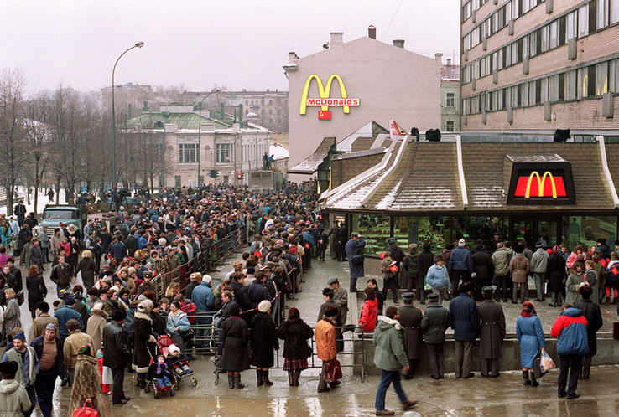

The Soviet Union was formed exactly 100 years ago, in the midst of a ruinous world war, promising to bring humanity to a new era of peace, prosperity, and equality. In the first decades of its existence, it amazed the world by rapidly transforming an agricutlural empire into a mighty superpower, destroying Nazi Germany, and launching man into space – and horrified it by acts of unimaginable brutality that left millions dead. In its final decades, it served as on of the two poles of a seemingly immutable world order - and then collapsed suddently, an earthquake that still reverbates on battlefields from Syria to Ukraine. The promises that the Soviet Union embodied and the antagonisms it generated were the defining feature of global politics in the 20th century, and in an era of growing global instability and political strife, its attempt to arrive at utopia still offer important lesson to observers of the 21st century. This class offers and overview of the Soviet experience and its aftermath, starting with the 1917 Revolution, and ending with Russian attempts to come to terms with the legacy of the Soviet Union in the early 21st century –terms that are now being negotiated on battlelines from Syria to Ukraine.

Books to Purchase

Sheila Fitzpatrick, The Russian Revolution, 3rd edition, New York: Oxford University Press, 2008.
Stephen Kotkin, Armageddon Averted, New York: Oxford University Press, 2008.
Ron Suny, The Structure of Soviet History: Essays and Documents, New York: Oxford University Press, 2003.

Week 1
Session 1. The background: late imperial Russia as a late modernizing society.
Read, From Tsar to Soviets, 1-46 [PDF]
Session 2. Russian Marxism and the Bolsheviks

Fitzpatrick, Revolution, 24-40. “Lenin's Concept of the Revolutionary Party,” in Dymytryshev, The Russian Empire: Source Book, 362-379 [PDF]
Week 2.
Session 3. War, the collapse of the Romanov monarchy and the February Revolution.
Fitzpatrick, Revolution, 32-49 Sergei Mstislavskii, Five Days which Transformed Russia, 17-78.(PDF)
Session 4: October Revolution

Boris Kolonistkii, “Antibourgeois Propaganda and anti-Burzhui consciousness in 1917”, in Suny, Structure, 22-31. Selections of sources from 1917, in Suni, Structure, 35-43. Mstislavskii, Five Days which Transformed Russia, 109-133 [PDF]

Week 3.
Session 5. Civil war and the making of the Bolshevik regime.

Fitzpatrick, The Russian Revolution, ch. 3, Bolshevik Decrees [PDF]

Session 6. From war Communism to NEP: restructuring and nationalities policy

Terry Martin, “Affirmative Action Empire,” in Suny, Structure, 93-102 Fitzpatrick, Revolution, 93-102, “Lenin's New Policy as He Explains it”, New York Times, 12/4/1921,

Week 4.
Session 7. Whither the Revolution? NEP and its dilemmas.
Fitzpatrick, Revolution, 96-111, Vladimir Brovkin, Russia after Lenin (PDF)
Session 8. The Great Break 1: collectivization and its consequences

Fitzpatrick, Russian Revolution, 135-141, Stalin, “Dizzy with Success” and Kopelev “Last Grain Collections,” Suny, Structure 209-222.

Week 5
Sessio

Session 9: The Great Break 2: the making of the socialist economy.

Fitzpatrick, Revolution, 130-135, “Stalin on Industrialization,Allen, From Farm to Factory [PDF]

Session 10. Cultural Revolution, cultural retrenchment and “Great Retreat”

Fitzpatrick, Revolution, 141-157m Dunham “Big Deal” and Timasheff, “Russia or World Revolution in Suny, Structure
.

Week 6
Session 11. Stalinism and Terror.

Fitzpatrick, Revolution, 163-172. Oleg Khlevniuk, “Objectives of the Great Purges.”(PDF),
Selection of sources on terror and purges, Suny, Structure, 232-251.
Session 12. The Soviet Union and the world.
Jonathan Haslam, “Comintern and Soviet Foreign Policy, 1919-1941 [PDF]
Week 7
Session 13. The German invasion: catastrophe and resilience.

Merridale, Ivan's War [PDF] John Barber, “Popular Reactions to the German Invasion in Moscow”, in Suny,
Structure, 263-272.
Session 14. Soviet Triumph.
Overy, Why Allies Won the War [PDF]

Week 8
Session 15. Postwar, Cold War
Zubok. Failed Empire, 1-94. Sources on Stalin and the cultural Cold War, Suny, Structure.
Session 16. The “Thaw” and its consequences.

Zubok, Failed Empire, 163-192 Robert Hornsby, “Voicing Discontent: Political Dissent from the Secret Speech to Khrushchev's Ouster,” in Soviet State and Society under Khrushchev, 162-180. Saburov, “1956: a Memoir,” and “Report by Head of KGB, 1962,” in Suny, Structure. “
Week 9
Session 17. Khrushchev’s Attempt at Communism

Kotkin, Armageddon Averted, 31-57. Deborah A. Field, “Irreconcilable Differences: Divorce and Private Life under Khrushchev” [PDF], “The Kitchen Table Debate” [Youtube]

Session 18. Soviet Union and the Cold War world.
Zubok, Failed Empire, 94-162.

Week 10
Session 19. The Brezhnev era: the politics of stability.
Zubok, Failed Empire, 192-265.
Content of Andrei Sakharov's KGB file [PDF]

Session 20. Everyday life under Brezhnev: Westernization, consumerism, social malaise.
Sergei Dovlatov, The Suitcase, selections (PDF)
Tatiana Zaslavskaia, “Novosibirsk Report,” [PDF]

Week 12

Session 21. Gorbachev as moderate reformer. Zubok, Failed Empire, 265- 303. Selection of Gorbachev's speeches, 1985-1987 [PDF]
Session 22: Collapse
Kotkin, Armageddon Averted
Von-Bremzen, Art of Soviet Cooking [PDF]

Week 13
Session 23: the Dark 1990s
Kotkin, Armageddon Averted, David Satter, Darkness at Dawn [PDF]
Session 24: Putin and a Resurgent Russia
Trenin, Post-Imperium, Kotkin, “Russia’s Persistent Geopolitics” [Both PDF]

Kotkin, Armageddon, 141-221

