HIST230 – The City of Rome: From Constantine to the Borgias
Fall 2017
Professor Ann Moyer
T 1:30-4:30
Cross Listings: ITAL230402
Office hours: T 1:30-3 and by appt.

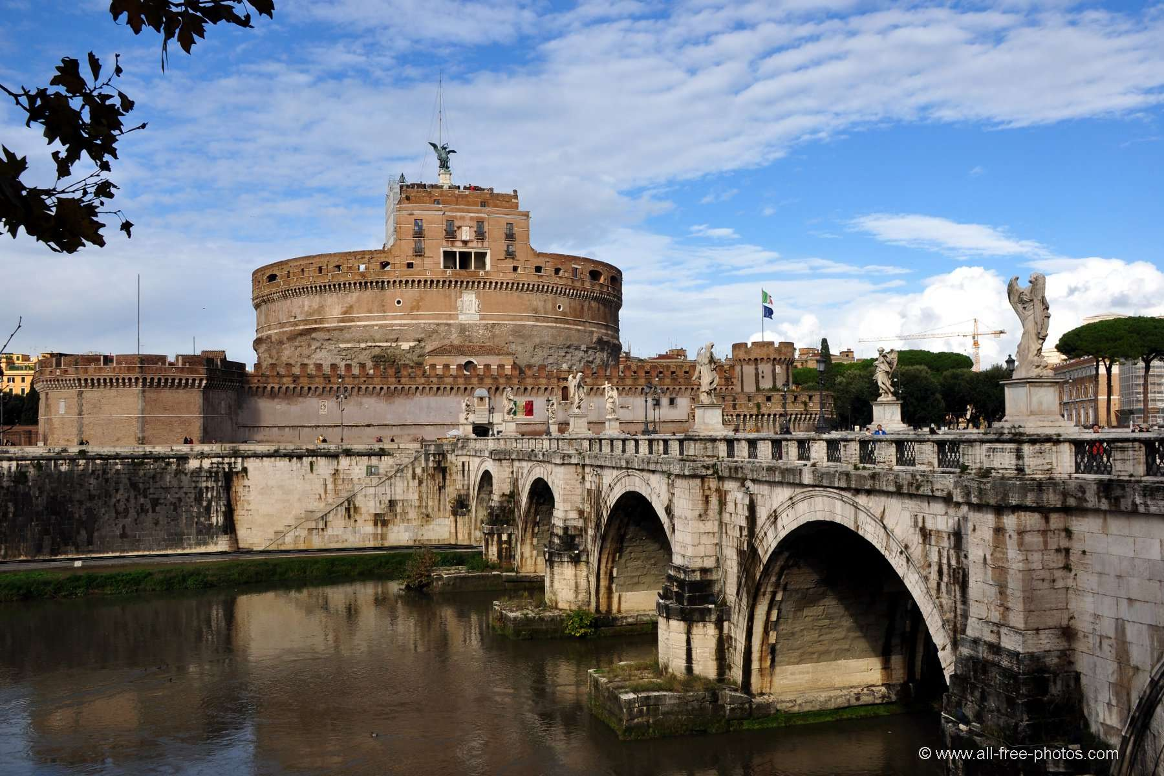

The great city of Rome outlived its empire and its emperors. What happened to the Eternal City after “the fall of the Roman Empire in the West?” In this course, we will follow the story of this great city, its people, its buildings old and new, and its legacy across Italy, Europe, and beyond.

Rome rebuilt and reshaped itself through the Middle Ages: home for popes, destination for pilgrims, power broker for Italy. It became a great Renaissance and early modern city, a center of art and architecture, of religion, and of politics.

We will be reading a mix of primary sources and modern scholarship. All required texts are in English, though students who take this course for Italian Studies credit may choose to read some works in Italian.

Books
Richard Krautheimer. Rome: Portrait of a City 312-1308
Richard Krautheimer. The Rome of Alexander VII
Ingrid Rowland. The Culture of the High Renaissance: Ancients and Moderns in Sixteenth-Century Rome
The Marvels of Rome; Mirabilia Urbis Romæ
Francesco Petrarch. The Revolution of Cola di Rienzo
Lorenzo Valla. On the Donation of Constantine

Additional readings on Canvas site.

1 | Aug 29 | Introduction: Rome and Later Antiquity  Krautheimer, Portrait of a City, Chapter 1
2 | Sept 5 | The Making of Papal Rome  Krautheimer, Portrait of a City Chapters 2-4;  Noble. The Republic of St. Peter, 1-60, 325-36 (Canvas)
3 | Sept 12 | Carolingians and Empire  Krautheimer, Portrait of a City, Chapter 5-6;  Liber pontificalis (Lives of the Eighth-C Popes), selections (Canvas)
4 | Sept 19 | From Bishops to Communes: the Roman Case  Krautheimer, Portrait of a City, Chapter 7;  Wickham, Medieval Rome 1-42, 385-457 (Canvas)
5 | Sept 26 | Rome for Travelers: the Mirabilia  Mirabilia Urbis Romae; Hamilton, Riccioni, articles from Rome Reimagined (Canvas)
6 | Oct 3 | Medieval Rome before Avignon  Krautheimer, Portrait of a City, Chapter 8-end
7 | Oct 10 | The Rise and Fall of Cola di Rienzi  Petrarch, The Revolution of Cola di Rienzo
8 | Oct 17 | Building a Renaissance in Rome: Popes and Humanists  D’Amico, Renaissance Humanism in Papal Rome, Part 1 and Conclusion (Canvas)  first book review due
9 | Oct 24 | Rome and its communities: Jews and Foreigners  Champagne et al., from Rome Re-Imagined;  Stow, from Jewish Life in Early Modern Rome;  Harvey, The English in Rome (selections) (Canvas)
10 | Oct 31 | Myths, Histories, and Humanists  Lorenzo Valla. On the Donation of Constantine
11 | Nov 7 | Anti-Clericalism, Abuses, and Reforms  Julius Exclusus; O’Malley, “Giles of Viterbo” (RQ) (Canvas); begin Rowland
12 | Nov 14 | Renaissance Culture: Ancients and Moderns  Rowland, The Culture of the High Renaissance
13 | Nov 28 | Natural Philosophy, Religious Controversy  Freedberg, Eye of the Lynx Chapters 1-5, 14 (Canvas)
14 | Dec 5 | Baroque Rome  Krautheimer, Rome of Alexander VII  Second book review due

Our course readings present a mix of major primary sources, synthetic summaries, and important modern scholarship. Most of our class time will focus on the information and issues they raise.

Course requirements:

- Weekly essays of ca 300 words responding to the week’s reading, due each week at the beginning of class, EXCEPT the weeks you will help lead discussion; the week a book review is due; and our first class meeting.
- Critical Book reviews: 2 reviews, 1000 words.
One review of your choice of assigned books; one of a scholarly work of your choice in Roman history, approved by instructor in advance. (We will have a list of suggested titles).
- Responsibility for introducing and leading the discussion of weekly readings (2 weeks), to be assigned the first week of class. Handout will be available first day of class; the assignment will include a written submission of your materials one week later.
- Take-home final essay examination.
- Regular attendance and participation

Attendance at our weekly meetings is, of course, mandatory. Please come ready to discuss the readings, with your copies of those readings in hand.

Grading percentages:
Review (each): 15%
Leading Discussion (each): 15%
Exam: 30%
Response papers and class participation: 10%

