HISTORY 415 / COML 419401
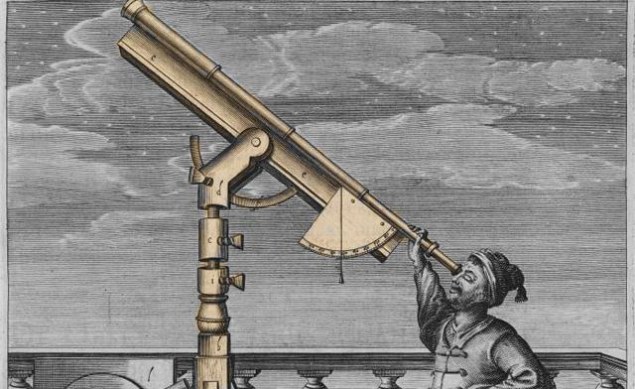
SEVENTEENTH-CENTURY EUROPEAN INTELLECTUAL HISTORY: ORIGINS OF MODERNITY
DR. DANIEL CHEELY
cheelyjm@sas.upenn.edu
FALL 2016
MW 2-3:30PM

Major Concentrations: Intellectual, European
Major/Minor Reqs Fulfilled: Europe, pre-1800

History 415 is an intellectual survey of one of the most revolutionary periods in the history of human interaction. It is the century when Europeans debated and changed fundamentally the ways in which they thought about knowledge, about intellectual authority and all other authority, about the nature of religion and its place within their world, about the scope of government and law, about human nature, about moral criteria, and about the possibilities of the human condition. We will read solely primary sources— seventeenth-century texts—seeking to understand them in their own right as well as the profound contemporary debates that they generated.
We will examine central currents of seventeenth-century European thought: experimentalism and empiricism, absolutism and contractualism, rationalism and skepticism. In short, the seventeenth-century in Europe produced an unprecedented challenge to the presumptive authority of the past, and it altered our world. This course focuses on works widely read in their own time and historically influential on the ages that followed. The course assumes no prior work in the subject, and there are no prerequisites.
We shall read, in English, authors who transformed Europe’s thought, debates, and civilization, either in their own right, or as part of broader movements of thought. Beginning with Aristotle (known as “The Philosopher” up to this period), we will move on to Francisco Suarez & Hugo Grotius, Francis Bacon, René Descartes (twice, in two very different works), Galileo, Blaise Pascal, John Milton, John Locke (twice, again, in two very different works), Thomas Hobbes, Baruch Spinoza, Isaac Newton, Pierre Bayle, and Mary Astell. You should witness, in these texts, the intellectual origins of modernity.
There will be an in-class mid-term exam (25% of your grade) and a regular, cumulative final exam (60%). There are no required papers, so that you have time to immerse yourselves in the readings, but if you have research interests or if you would prefer not to have only exams determine your grade, you may choose to write a paper, which would count as half of your final-exam grade (30%). Participation will count as 15%. Each week I will post “Questions for Reading” and you will post one follow-up question yourselves each week. Our discussions, therefore, will be open to your own interests and questions.
Class Schedule
08/31: Organizational meeting & The Philosopher (Aristotle’s Physics II.3, brief selections in class)
09/05, 9/07: Introduction: Metaphysics, Theology & Law: What You Learned at the Universities in 1600 Francisco Suarez, De Legibus (On the Laws) II:6 and Disputationes Metaphysicae (Metaphysical Disputations: Demonstration of the Existence of God): 28 & 29, and Hugo Grotius, De Jure Belli ac Pacis (On the Law of War & Peace), brief selections.
09/12, 9/14: Bacon, Selected Philosophical Works, 66-148 (top)
09/19, 9/21: Galileo, The Essential Galileo, 17-25, 97-102, 109-145, 179-201, 288-94, 300-306, 334-56
09/26, 9/28: Descartes, Meditations on First Philosophy, 1-59
10/3, 10/5: Descartes, The Passions of the Soul, 1-87
10/10: Mid-Term Exam
10/12: Hobbes, Leviathan, 3-110 (top)
10/17, 10/19: Pascal, Pensées, 3-75, 105 (“Christian Morality”)-112, 181-200, 225-233, 285-286 (top)
10/24, 10/26: Spinoza, Theological-Political Treatise, 1-115, 145-172, 222-230
10/31, 11/2: Locke, Essay Concerning Human Understanding, 1-78, 117-50, 166-87, 192-203, 208-54
11/7, 11/9: Locke, Reasonableness of Christianity, 24-77.
11/14, 11/16: Newton, Newton’s Philosophy of Nature, 1-67, 105-34, 173 (bottom)-179
11/21: Religious Toleration in Europe . John Milton, Areopagitica.
11/23: Thanksgiving Schedule ~ No Class Wednesday
11/28, 11/30: Pierre Bayle, Historical & Critical Dictionary, 45-63, 144-53, 166-209, 350-88, 395-444
12/05, 12/7: Mary Astell, A Serious Proposal to the Ladies, Part II: Wherein a Method is offer’d for the Improvement of their Minds, Selections.
12/12: Final Class: General Discussion

